How does evolution result in similarities and differences?

Evolution of Similarities and Differences in Mammals and Insects

The basic structure of the skeleton is similar in all mammals. We will illustrate this by comparing the skeletons of squirrels and bats.

1. Label at least four types of bones in this squirrel skeleton.

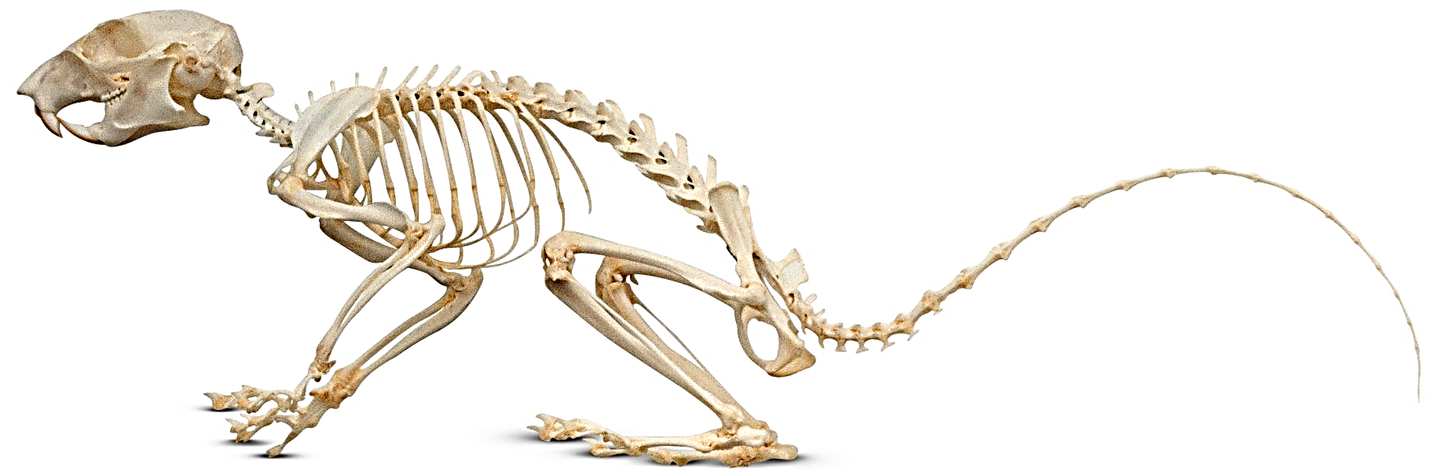

This figure shows most of the skeleton of a bat. The light shading represents a wing, which is supported by very long finger bones, an arm, the body, and a leg.  2. Label each type of bone in the bat skeleton that corresponds to a labeled bone in the squirrel skeleton.  3a. What are the biggest differences between the bat skeleton and the squirrel skeleton? | 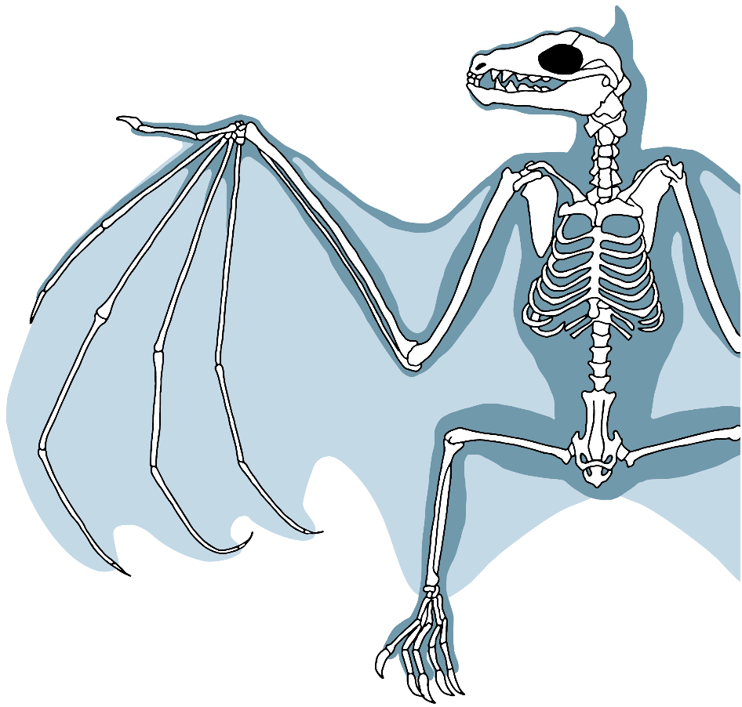

3b. Explain how the differences between squirrel and bat skeletons are related to the difference in how they move.

4. Fossil evidence indicates that the evolutionary ancestors of all mammals had a skeleton that was similar to a squirrel’s skeleton. How do you think that the long finger bones of bats evolved?

All mammals have many similar characteristics, including the following.
- The basic structure of the skeleton is similar in all mammals.
- All mammalian bones are made of proteins and the mineral, calcium phosphate.
- In all mammals, the mother produces milk to feed her young.
- All mammals have similar types of lungs, heart, and blood vessels.
The many similarities indicate that the shared evolutionary ancestors of all mammals had these characteristics and contemporary mammals inherited these characteristics from their shared evolutionary ancestors.

5. What caused the many similarities between bat and squirrel skeletons?

There are more than one million species of insects alive today, including many species of each type of insect shown below. All these species have many shared characteristics.  For example, all insects have skeletons on the outside, like a suit of armor. This type of external skeleton is called an exoskeleton. (Exo- means on the outside or external.) The tough insect exoskeleton is made of proteins and a polysaccharide called chitin. The exoskeleton provides both support and protection for the insect. In addition to an exoskeleton made of proteins and chitin, every insect has:  - three pairs of legs with joints and  - a head with a pair of antennae  - a similar type of circulatory system. | 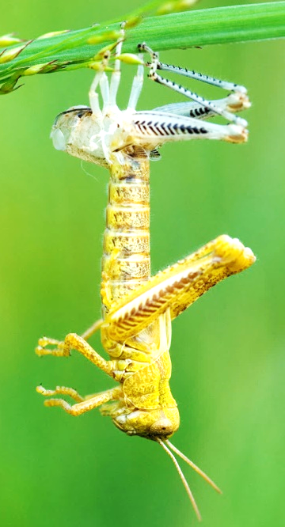  This figure shows a grasshopper emerging from its old exoskeleton. The tough exoskeleton doesn’t stretch as an insect grows. Therefore, in order to get bigger, an insect has to shed its old exoskeleton. Under the old tough exoskeleton is a new soft exoskeleton, which the insect expands before the new exoskeleton gets too tough to stretch.

6. Fill in the boxes to indicate the evolutionary relationships for bats, crickets, grasshoppers, and squirrels.

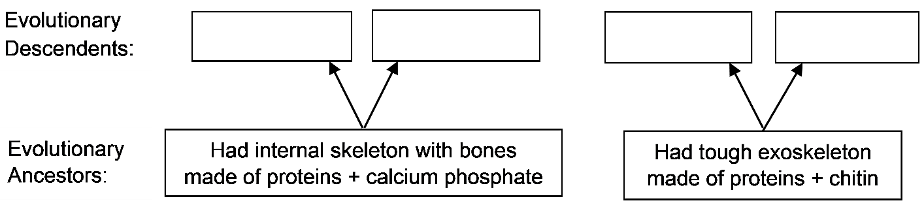

To learn what insect wings and bat wings are made of, read the captions for the figures.  7. Explain the evolutionary reason why insect wings and bat wings are made of different materials.  8. Describe the similarities between the shapes of insect wings and bat wings. | 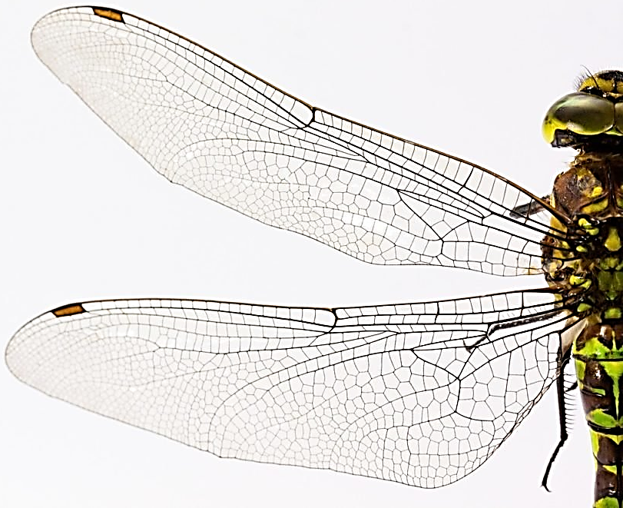  Insect wings are made of thin exoskeleton (proteins and chitin). The lines in the wings indicate thicker supporting “veins”. Typical insect wings are <1 mm thick.

Because insect and bat wings are made of very different materials, we can conclude that the similar shape of these wings is not due to inheritance from a shared evolutionary ancestor. Thus, there must be a different evolutionary reason for the similar wing shapes. | 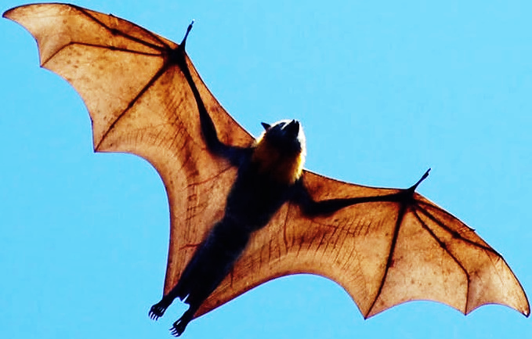  Bat wings are made of skin (<1 mm thick). The skin is supported by long finger bones and by the arms, body and legs.

9. Suggest a hypothesis to explain how evolution resulted in the similar shapes of insect wings and bat wings.

- A homologous characteristic is similar in different animals due to inheritance from a shared evolutionary ancestor that also had this characteristic.
- An analogous characteristic is similar in different animals due to independent evolution of similar characteristics to accomplish the same function.

Biologists use a lot of information to figure out whether a similar characteristic in two animals is homologous or analogous. Important clues include:
- Animals with many shared characteristics probably inherited these characteristics from a shared evolutionary ancestor, so these are probably homologous characteristics. For insects, their exoskeleton and other shared characteristics are homologous characteristics.
- Characteristics that have a similar function and appearance, but are made of different types of materials, are analogous characteristics.

10a. Give an example of a homologous characteristic in two different mammals.

10b. What evidence supports your conclusion that this characteristic is homologous?

11a. Give an example of an analogous characteristic in two different animals.

11b. What evidence supports your conclusion that this characteristic is analogous?

Laboratory Investigation
Which two of the animals shown below are more closely related evolutionarily? To find out, you will investigate the characteristics of these animals.
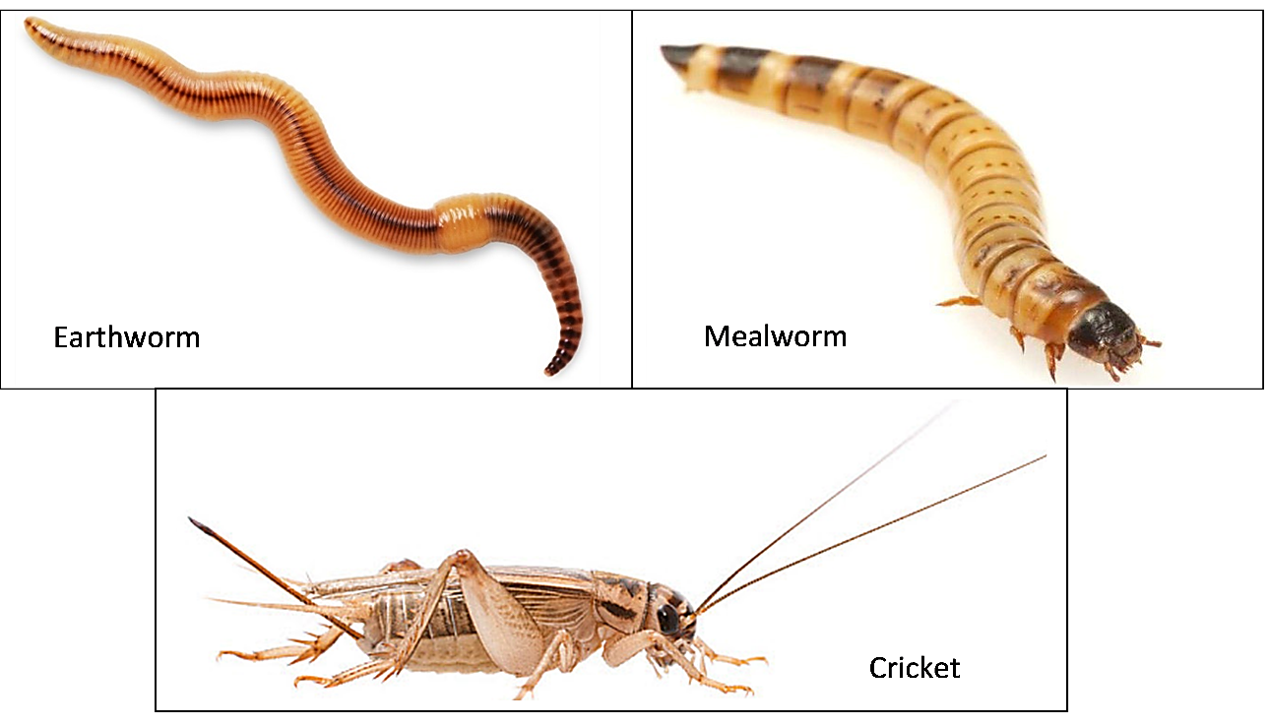
12. Begin by guessing which two of these animals are more closely related evolutionarily. Explain your reasoning.

The earthworms, mealworms, and crickets will probably be at different stations. Your teacher will tell you which station you should visit first.

Earthworms
Earthworms can dry out easily, so cover any earthworms you are not observing with a damp paper towel. Handle the earthworms gently and be careful not to injure them. Observe their external appearance and behavior. Look at them with a magnifying glass, hand lens, or dissecting microscope. Turn them over and observe what’s underneath.

13. Complete the table below.

Describe what you see. |  |  | Describe the shape of the body. | Is the outer surface |  | Other
Legs? | Antennae? | Eyes? |  | soft or tough? | damp or dry? | Observations

14a. Take two or three earthworms out of the container and place them on a damp paper towel on a plate. Observe an earthworm as it moves. Do different segments of the earthworm get shorter or longer, fatter or thinner as the earthworm moves? yes ___ no ___
Describe any changes in shape that you observe.

14b. How does an earthworm move? Relate your explanation to your answer to question 14a.

Mealworms
Handle the mealworms gently and be careful not to injure them. Observe their external appearance and behavior. Look at them with a magnifying glass, hand lens, or dissecting microscope. Turn them over and observe what’s underneath.

15. Complete the table below.

Describe what you see. |  |  | Describe the shape of the body. | Is the outer surface |  | Other
Legs? | Antennae? | Eyes? |  | soft or tough? | damp or dry? | Observations

16a. Take two or three mealworms out of the container and place them on a dry paper towel on a plate. Observe a mealworm as it moves. Do different segments get shorter or longer, fatter or skinnier as the mealworm moves? yes ___ no ___
Describe any changes that you observe.

16b. How does a mealworm move?

Crickets
You can pick up the container to examine the crickets, but do not open the container. Observe the external appearance and behavior of the crickets.

17. Complete the table below.

Describe what you see. |  | Describe the shape of | Other observations
Antennae? | Eyes? | the body.

18a. Describe the differences between the cricket’s back pair of legs and the front two pairs of legs.

18b. How do the front two pairs of legs help a cricket move?

18c. How does the back pair of legs help a cricket move?

19a. Do you think that the outer surface of a cricket is soft ___ or tough ___?

19b. Explain your reasoning.

Analysis and Discussion Questions
In nature:
- Earthworms burrow in the soil where they eat dead organic matter (e.g. dead leaves) and microorganisms (e.g. bacteria).
- Mealworms burrow through stored grain, which they eat.
- Crickets hide under rocks and logs. They come out at night to feed on plants and small insects.

20. Propose a hypothesis to explain why mealworms can survive in dry stored grain, but earthworms could not. (Hint: Think about their different body surfaces.)

21a. Earthworms and mealworms have a somewhat similar appearance, since they both have a long thin body. Why is this useful for these burrowing animals?

21b. Review the definitions of homologous and analogous characteristics on the top of page 4. Do you think that the similar long thin body shapes are an example of
analogous characteristics ___ or homologous characteristics ___?

21c. Explain your reasoning.

22. Complete this Venn diagram. In the appropriate sections, include:
- any characteristics you have observed in all three animals,
- any characteristics shared by any two of these animals, and
- any characteristics that you observed in only one of these animals.

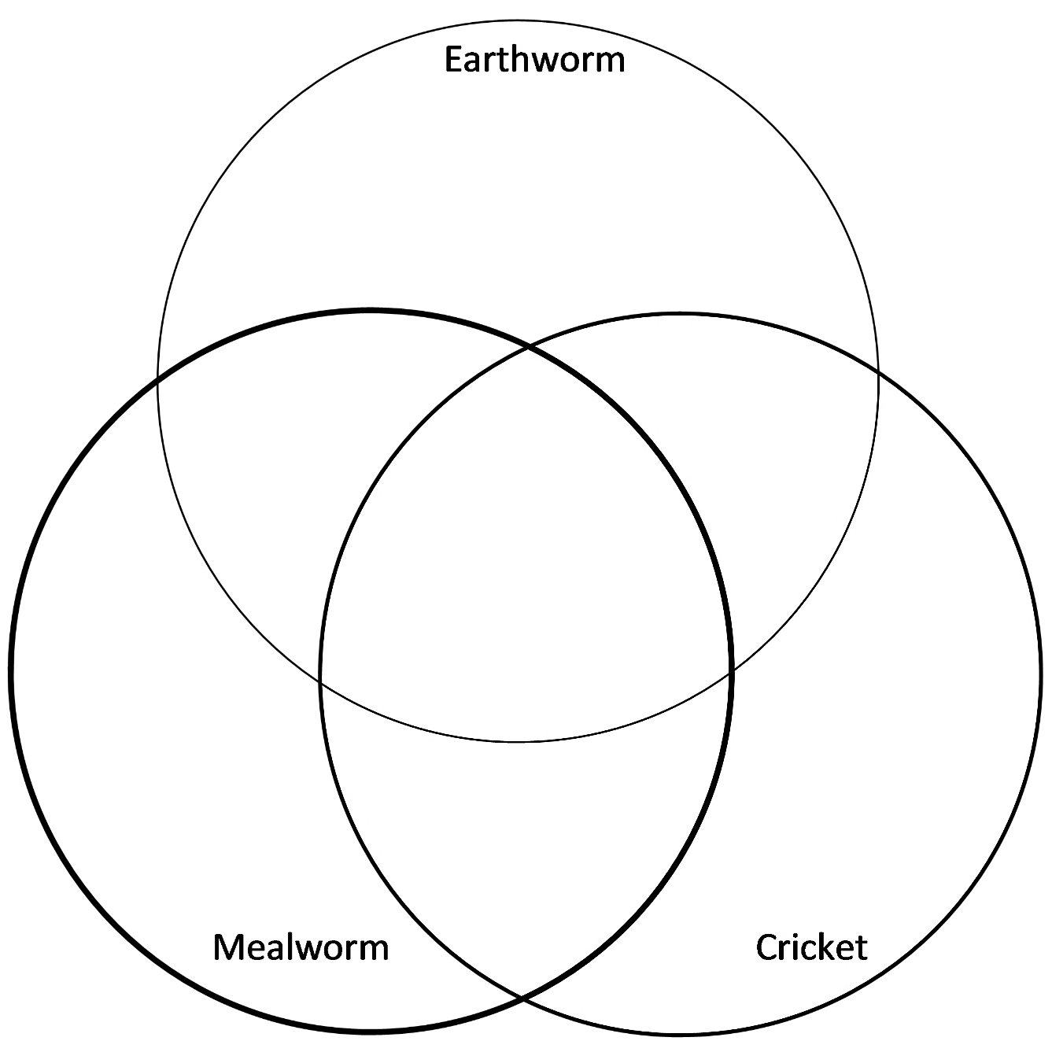

23a. Based on everything you have learned, which two of these three animals are more closely related evolutionarily?

23b. Explain your reasoning. Your answer should include examples of similarities that are homologous characteristics.

By Dr. Ingrid Waldron, Department of Biology, University of Pennsylvania, © 2024. This Student Handout and Teacher Notes (with background information and instructional suggestions) are available at http://serendipstudio.org/exchange/bioactivities/EvolSimil.

